**ORDER**

**Nr.56 ,date 5.4.2024**

**FOR**

# APPROVAL OF THE STRUCTURE AND ORGANIZATION

# OF THE NATIONAL AGENCY FOR CANNABIS CONTROL

# In accordance with Article 3 of Article 102 of the Constitution, Article 10 of Law No. 9000, dated January 30, 2003, "On the organization and functioning of the Council of Ministers," and Article 21 of Law No. 90/2012, "On the organization and functioning of the state administration,"

**I ORDER:**

The structure of the National Agency for Cannabis Control shall be according to Scheme 1, attached to this order and integral part thereof.

The organization chart of the National Agency for Cannabis Control shall be according to Scheme 2, attached to this order and integral part thereof.

The total number of employees of the National Agency for Cannabis Control shall be 43 persons.

This order shall enter into force immediately**.**

# PRIME MINISTER

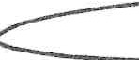

SCHEME 1

|  |  |  |
| --- | --- | --- |
|  | | SCHEME 2 |
| THE ORGANIZATION CHART OF THE NATIONAL CANNABIS CONTROL AGENCY |  |  |
| POSITION | KATEGORY | NUMBER |
| 1 GENERAL DIRECTOR | I-3 | 1 |
| 2 COORDINATOR | II-1 | 4 |
| 3 DIRECTORY OF STANDARTS, AUTHORISATIONS, PERMITS AND LINCENSING |  | 19 |
| **DIRECTOR** | II-1 | **1** |
| 3.1 **Sector of Standards, Statistics, and Innovation** |  | 7 |
| COORDINATOR (DIRECTOR) | II-1 | 1 |
| COORDINATOR | 11-1 | 5 |
| SPECIALIST | IV-1 | 1 |
| 3.2 **Sector of Authorizations, Permits, and Licenses** |  | 7 |
| COORDINATOR (DIRECTOR) | 11-1 | 1 |
| COORDINATOR | 11-1 | 3 |
| COORDINATOR (LAWYER) | 11-1 | 1 |
| COORDINATOR (FINANCE) | 11-1 | 1 |
| SPECIALIST | IV-1 | 1 |
| 3.3 **SECTOR OF PERSONNEL SECURITY 4**  -----------------------------------------------------------------------------------------------------------------------------------------------------------··-------------------------------- | | |
| COORDINATOR (DIRECTOR) | II-1 | 1 |
| COORDINATOR | II-1 | 2 |
| SPECIALIST | IV-1 | 1 |

·

Faqe 1 nga 2

|  |  |  |  |  |  |
| --- | --- | --- | --- | --- | --- |
| POSITION | | | | CATEGORY | NUMBER |
| **DIRECTORATE OF OVERSIGHT, CONTROL, AND INSPECTION OF CULTIVATION, PRODUCTION, AND DISTRIBUTION OF INDUSTRIAL CANNABIS**  4 | | | |  | 7 |
| DIRECTOR | | | | II-1 | 1 |
| COORDINATOR | | | | II-1 | 3 |
| SPECIALIST | | | | IV-1 | 3 |
| **DIRECTORATE OF OVERSIGHT, CONTROL, AND INSPECTION OF CULTIVATION, PRODUCTION, AND DISTRIBUTION OF MEDICAL CANNABIS** | | | |  |  |
| 5 | | | |  | 7 |
|  | DIRECTOR |  |  | 11-:l | 1 |
|  | COORDINATOR |  |  | 11-:l | 3 |
|  | SPECIALIST |  |  | IV--1 | 3 |
| 6 | **DIRECTORATE OF GENERAL SERVICES** |  |  |  | **5** |
|  | DIRECTOR |  |  | 11-2 | 1 |
|  | SPECIALIST |  |  | IV--2 | 2 |
|  | SPECIALIST (SEKRETARY ARCHIVE) |  |  | IY.-2 | 1 |
|  | DRIVER |  |  |  | 1 |

# PUNONJES GJITHSEJ 43

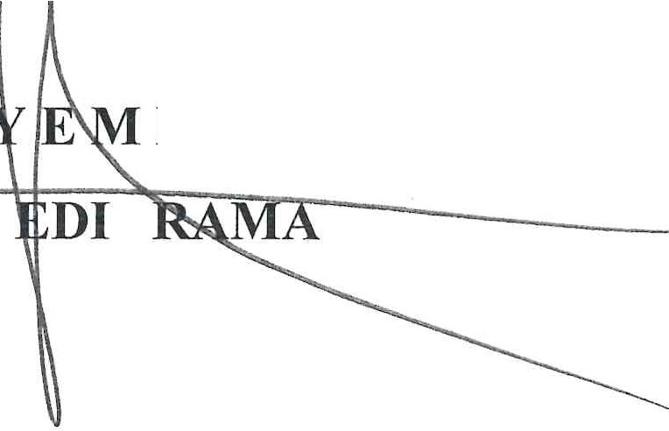

**KR INISTRI**

Page 2 of 2